CS115 Fall 2018: Review questions

JavaScript
What value is printed in the alert box for the following JavaScript program?

var words=["bon","go"];
var ans1 = words[1] + words[0];
var word1 = words[0];
var word2= ans1;
var ans2 = word1 + word2;
words[1] = "wiki";
alert(ans1 + "," + ans2);

Write JavaScript function that takes in an integer argument n, and check if it is within a distance of 10 from 100 or 200. Return true if n is in the said distance.

Write some JS code that does the following:
- Prompt the user to confirm that they graduated from high school
- Only if they did, prompt the user to enter their graduation year from high school
- Alert the user back with a message saying “You graduated X years ago” where X is the number of years between the input year and the current year.

CSS
How do you add (using document level CSS) a background color for all <h1> elements in the document?

How do you select an HTML element with id "important"?

Given the following HTML snippet, write document level CSS code to style the page similarly to the image below (except the black border):
<h1> CS Intro Courses </h1>
<p> Here is the list of intro to CS courses accepted for credit at Wellesley:
</p>
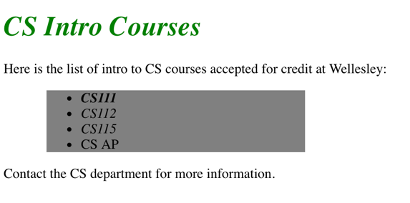
<ul id="intro_courses">
<li class="course" id="major">CS111</li>
<li class="course">CS112</li>
<li class ="course" id="mas">CS115 </li>
<li> CS AP </li>
</ul>
<p> Contact the CS department for more information.
</p>

General
Use the Vigenere square below and the key: asimov to encrypt the following text:
“A robot may not injure a human”.

Explain the following terms:
- Intersection attack
- third-party cookie
- human computation
- crowdsourcing
- Captcha

Describe two factors that can cause algorithmic bias?

